**CSE443/543: High Performance Computing**

**Exercise #19: Collective communication**

Points: 40

|  |
| --- |
| **Objective**: The objective of this exercise is to:   * Gain familiarity with collective communication. * Understand the use of MPI collective communication operations. * Learn to run MPI programs via SLURM on a compute cluster.     **Submission**: Upload the following at the end of the lab exercise via Canvas CODE plugin:   1. This MS-Word document saved as a PDF file with the convention MUID_Exercise19.pdf. 2. The program you completed as part of this exercise with the source file named with the convention MUID_exercise19.cpp. |

# Part #0: Review online lecture

|  |  |
| --- | --- |
|  | **Required video review**:  Prior to working on this exercise, ensure you review the lecture video on collective communications on Canvas. |

# Part #1: Short answer questions

Provide a brief (2-to-3 sentences) response to each of the following questions.

1. What is a virtual synchronization point? Explain with a suitable MPI call. How is it different from a barrier?
   1. 2 Advantages

|  |
| --- |
| A virtual synchronization point is where all processes call the same function with the same parameters and the processes do not block each other.  int i = 10, dest;  brodcast(world, i, dest, 0);  A barrier blocks processes until all processes have called the barrier function at which it unblocks. |

1. Briefly describe 2 significant differences between conceptual broadcast versus scatter operations

|  |  |
| --- | --- |
| ***Broadcast*** | ***Scatter*** |
| Same value sent to all the processes | Different values are sent to different processes |
| Amount of data received by each process is the same | Amount of data received by each process can vary |

1. Given the following MPI code fragment from process with rank 0, complete the complementary collective operation on other processes

|  |
| --- |
| **void** **doManagerTasks**(const std::string& data) {  int strSize = data.size() + 1;  MPI_Bcast(&strSize, 1, MPI_INT, 0, MPI_COMM_WORLD);  MPI_Bcast(&data[0], size, MPI_CHAR, 0, MPI_COMM_WORLD);  } |

|  |
| --- |
| std::string **recvData**() {  int strSize = 0;  MPI_Bcast(&strSize, 1, MPI_INT, 0, MPI_COMM_WORLD);  std::string data(strSize);  MPI_Bcast(&data[0], size, MPI_CHAR, 0, MPI_COMM_WORLD);  return data;  } |

# Part #2: Programming with collective communication

In this part of the exercise, you will be required to complete 3 interview/exam style questions in the supplied exercise19.cpp starter code.

## Part #2.1: Setting up VS-Code project

*Estimated time to complete: 5 minutes*



1. Log into OSC’s OnDemand portal via <https://ondemand.osc.edu/>. Login with your OSC id and password.
2. Startup a VS-Code server and connect to VS-Code. Ensure you switch to your workspace. Your VS-Code window should appear as shown in the adjacent screenshot.
3. Next, create a new VS-Code project in the following manner:
   1. Start a new terminal in VS-Code
   2. In the VS-Code terminal use the following commands:

|  |
| --- |
| $ # First change to your workspace directory  **$ cd ~/cse443**  $ # Use ls to check if workspace.code-workspace file is in pwd  $ # Next copy the basic template for a C++ project  **$ cp -r /fs/ess/PMIU0184/cse443/templates/mpi exercise19**  $ # Copy the starter code for this exercise  **$ cp /fs/ess/PMIU0184/cse443/exercises/exercise19/* exercise19** |

## Part #2.2: Mean and variance

In the supplied exercise19.cpp starter code, implement the getMeanAndVar method. The getMeanAndVar method is called on **n** processes of an MPI program. Each process will have a different value (as shown in the figure below). This method must be implemented to compute and return the mean and variance on every process (as shown in the figure below). **Note that your implementation must use only collective communication and computation operations**. Hint: all_reduce.

|  |  |  |
| --- | --- | --- |
|  |  |  |

**Expected output(s):**

|  |
| --- |
| **$ srun -A PMIU0184 -n 3 ./exercise19 q1 1 -2 3**  srun: job 7294937 queued and waiting for resources  srun: job 7294937 has been allocated resources  mean: 0.666667, variance: 4.22222 |
|  |
| **$ srun -A PMIU0110 -n 4 ./exercise19 q1 1 2 3 4**  srun: job 7301859 queued and waiting for resources  srun: job 7301859 has been allocated resources  mean: 2.5, variance: 1.25 |
|  |

## Part #2.3: Aggregate

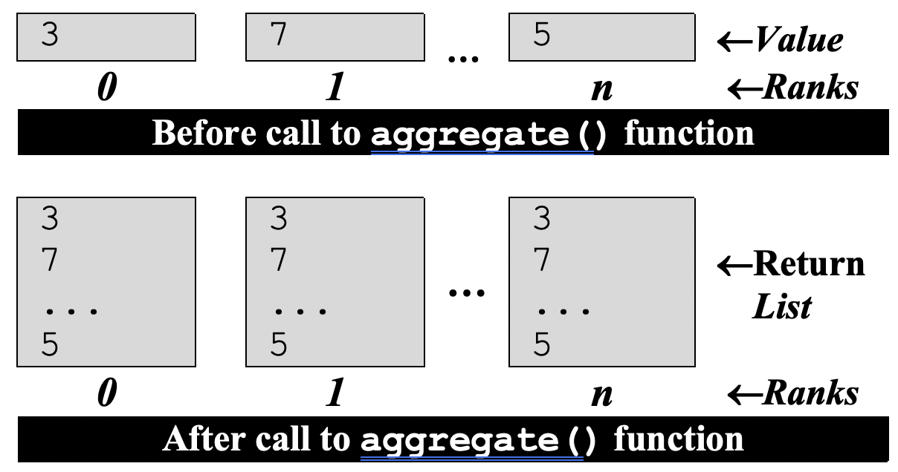In the supplied exercise19.cpp starter code, implement the aggregate method. The getMeanAndVar method is called on **n** processes of an MPI program. Each process will have a different value (as shown in the adjacent). This method must be implemented to collect/aggregate the values (in order of rank) from all processes into a vector and return the vector in all processes.

**Expected output(s):**

|  |
| --- |
| **$ srun -A PMIU0110 -n 4 ./exercise19 q2 1 2 3 4**  srun: job 7302122 queued and waiting for resources  srun: job 7302122 has been allocated resources  List[0] = 1  List[1] = 2  List[2] = 3  List[3] = 4 |
|  |
| **$ srun -A PMIU0110 -n 4 ./exercise19 q2 1 5 9 3 7**  srun: job 7302677 queued and waiting for resources  srun: job 7302677 has been allocated resources  List[0] = 1  List[1] = 5  List[2] = 9  List[3] = 3  List[4] = 7 |

## Part #2.2: Print in-order

In the supplied exercise19.cpp starter code, implement the printInOrder method. This method is called on all processes of an MPI program. Each process will have a different value supplied as the parameter. Implement this method to print the value (on each process) in the order of the rank of the process. Hint: barrier in a loop and the ith process prints in the ith iteration of the loop.

**Expected output(s):**

|  |
| --- |
| **$ srun -A PMIU0110 -n 5 ./exercise19 q3 1 5 9 3 7**  srun: job 7302925 queued and waiting for resources  srun: job 7302925 has been allocated resources  Value at rank #0 = "data on 0 is 1_0"  Value at rank #1 = "data on 1 is 1_1"  Value at rank #2 = "data on 2 is 1_2"  Value at rank #3 = "data on 3 is 1_3"  Value at rank #4 = "data on 4 is 1_4" |
|  |
| **$ srun -A PMIU0110 -n 3 ./exercise19 q3 test**  srun: job 7302964 queued and waiting for resources  srun: job 7302964 has been allocated resources  Value at rank #0 = "data on 0 is test_0"  Value at rank #1 = "data on 1 is test_1"  Value at rank #2 = "data on 2 is test_2" |

# Part #3: Upload solution to Canvas

Once you have successfully completed and tested the program, submit the following via the Canvas CODE plugin

1. This MS-Word document saved as a PDF file with the convention MUID_Exercise19.pdf.
2. The program you completed as part of this exercise with the source file named with the convention MUID_exercise19.cpp.

**Ensure you actually complete the submission process in Canvas (after you accept submission in CODE).**